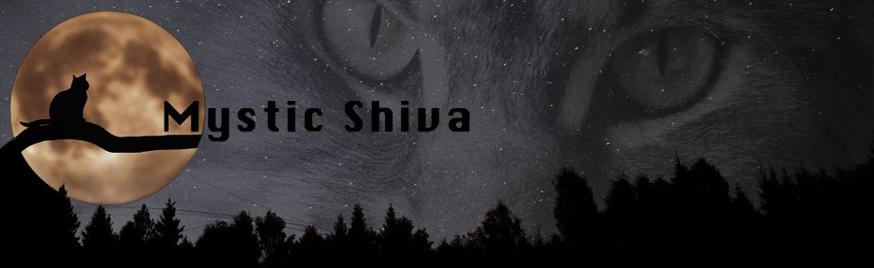
DISNEY
 |  | Aurora | Verschil |  | Marlin | Verschil |  | Milo | Verschil
 |  | Poes |  |  | Kater |  |  | Kater
10-2-2021 |  | 138 |  |  | 146 |  |  | 152
17-2-2021 |  | 212 |  |  | 242 |  |  | 239
24-2-2021 |  | 334 |  |  | 329 |  |  | 359
3-3-2021 |  | 449 |  |  | 421 |  |  | 473
10-3-2021 |  | 596 |  |  | 540 |  |  | 625
17-3-2021 |  | 650 |  |  | 620 |  |  | 758
24-3-2021 |  | 868 |  |  | 832 |  |  | 968
31-3-2021 |  | 1040 |  |  | 1050 |  |  | 1200
7-4-2021 |  | 1330 |  |  | 1280 |  |  | 1455
14-4-2021 |  | 1570 | 1432 |  | 1595 | 1449 |  | 1765 | 1613

